QUIZ 2 Part 2 Week 4-5-6

1. After a $5 million ad campaign, Coca-Cola measured its effectiveness by calculating the cross elasticity of demand between Coke and Pepsi. A successful campaign would be indicated if the cross elasticity went from

|  |
| --- |
| ___________.   1. In January, 2,500 quarts of ice cream are sold in Boston at $2 a quart. In February, 3,000 quarts are sold at $2.50 a quart. This change in quantity sold and price may have been caused by   a. the introduction of labour-saving automated ice cream-packing machinery.  b. the release of a medical study showing that ice cream consumption improves mental health.  c. a reduction in wages in the Boston area.  d. the decision by Boston ice cream sellers to eliminate discount coupons. |
|  |
| 1. A decrease in supply will have what effect on equilibrium price and quantity?   a. Price will decrease; quantity will increase.  b. Price will increase; quantity will decrease.  c. Both price and quantity will increase.  d. Both price and quantity will decrease.   1. In Figure 6-2, the price elasticity of demand (dropping all minus signs) is ____ between P = 4 and P = 6 than between P = 10 and P = 12 because between the lower set of prices the percentage change in price is ____.   a. smaller; greater  b. greater; smaller  c. smaller; smaller  d. greater; greater |
|  |

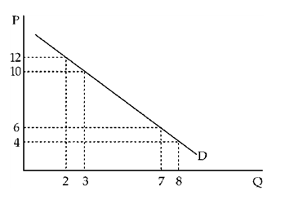

1. Normally, to the extent that a governmental control mechanism succeeds in affecting price, it can be expected to lead to a corresponding

a. reduction in the volume of sales if the price is forced down and an increase in the volume of sales if the price is forced up.

b. increase in the volume of sales whether the price is forced up or down.

c. decrease in the volume of sales whether the price is forced up or down.

d. reduction in the volume of sales only if the price is forced down.

1. Which of the following is a symptom of a price floor?

a. milk shortages

b. the New York city housing shortage

c. black markets

d. scalping of Super Bowl tickets

e. surplus cheese

1. In Figure 5-2, consumer surplus is measured by the area

a. OACD.

b. ABC.

c. OBCD.

d. DCE.

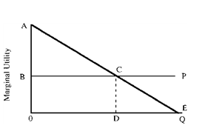

1. The price elasticity of new automobile purchases is about 1.2. This implies that an increase of $1,000 on a $10,000 automobile will

a. reduce the number of autos sold by approximately 12 percent.

b. increase the consumer expenditures on autos by approximately 1.2 percent.

c. increase consumer expenditures on autos by approximately 12 percent.

d. reduce the number of autos sold by approximately 1.2 percent.

1. Because of falling oil prices in the past, Libya could afford fewer imported goods. Government controls were established to limit imports of cigarettes. In 1985, the market price of Marlboros rose to $70 a carton. Which graph in Figure 4-22 best depicts this situation?

a. 4

b. 2

c. 1

d. 3

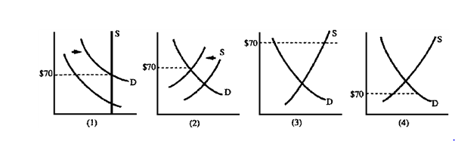

1. Suppose that the supply of insulin is perfectly elastic and the demand for insulin perfectly inelastic. Then the result of an excise tax would be

a. no increase in government revenue and no change in the quantity consumed.

b. a significant increase in government revenue and a significant decrease in the quantity consumed.

c. a significant increase in government revenue and no change in the quantity consumed.

d. a significant decrease in the quantity consumed with no change in government revenue.

1. A recent study on enrolment at a liberal arts college concluded that demand elasticity is 0.91. The administration is considering a tuition increase to help balance the budget. The revenue-maximizing decision is to

a. decrease tuition, which should boost enrolment enough to balance the budget.

b. decrease tuition, which would bring in more revenue.

c. increase tuition, which would bring in more revenue.

d. leave tuition as is-an increase would not help balance the budget.

1. If the government has stated that it will pay whatever it must to obtain 1,000 units of good X, which demand curve in Figure 4-1 is appropriate?

a. 2

b. 3

c. 4

d. 1

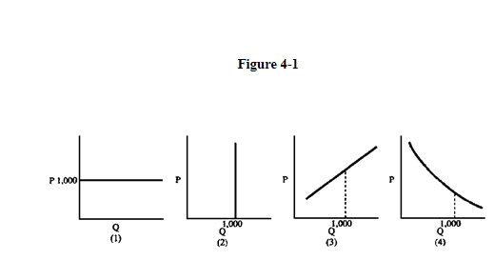

1. Assume that Figure 4-4 shows demand for MP3 players. An increase in the price of music downloads changes demand from

a. D1 to D3.

b. D2 to D1.

c. D2 to D3.

d. D1 to D2.

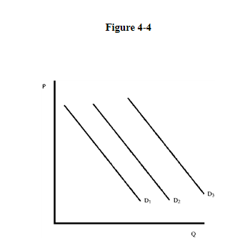

1. At price P3 in Figure 4-21, what will tend to happen?

a. Equilibrium will occur in the market.

b. There will be a shortage, and the price will rise.

c. There will be a surplus, and the price will rise.

d. There will be a shortage, and the price will fall.

e. There will be a surplus, and the price will fall.

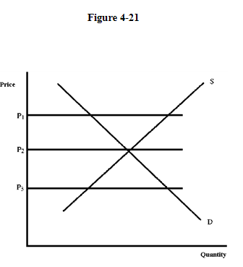

1. The Wall Street Journal reports that "hard times aid poultry companies as people eat cheaper fowl." In the language of economists, this means

a. chicken has a negative substitution effect.

b. chicken is an inferior good.

c. people's tastes change during recessions.

d. chicken has a positive income effect.

e. chicken has a positive substitution effect.

1. A shift in the budget line in Figure 5-6 from AB to AC indicates

a. All of the above are correct.

b. the price of beer has fallen.

c. the price of wine coolers has risen.

d. income has increased.

e. the price of wine coolers has fallen.

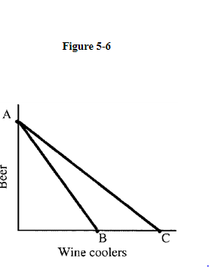

1. In Figure 5-13, the consumer is better off

a. at B than at D.

b. All of the above are correct.

c. at A than at E.

d. at any point on U2 than at any point on U1.

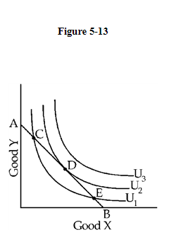

1. ​If marginal utility is a positive number:

a. ​the more you purchase, the more total utility you get

b. ​none of these is correct

c. ​utility is not affected by more purchases

d. ​the more you purchase, the less total utility you get

1. Some medical authorities announced in the late 1980s that an acne medicine named Retin-A also had previously unknown wrinkle-reducing properties. An economist would expect to find that, after this announcement, the price of Retin-A ____ and the quantity sold ____.

a. rose; rose

b. fell; fell

c. fell; rose

d. rose; fell

1. The elasticity of supply is calculated by

a. dividing the percentage change in quantity supplied by the percentage change in price.

b. dividing the absolute change in quantity supplied by the absolute change in price.

c. dividing the percentage change in price by the percentage change in quantity demanded.

d. determining the slope of the supply curve.